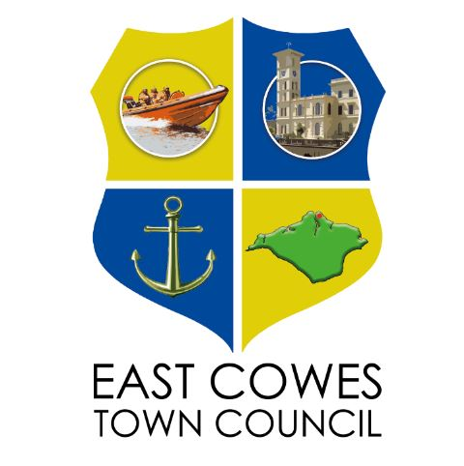

VOLUNTEER POLICY

2026

This policy applies to all volunteers working on behalf of, but not employed by, East Cowes Town Council, whether working for only a few hours to help at an event or volunteering on a regular basis.
Volunteers undergo an induction appropriate for the task(s) being undertaken. This includes initial training relevant to their role provided by their line manager or by Library Headquarters Staff, health and safety, what to do if there is a problem and an introduction to other relevant individuals. Overall responsibility for the induction rests with the individual authorised by East Cowes Town Council.
Volunteers are provided with training and information relevant to their role including council policies and procedures. This will depend on:
• The job or activity
• The existing competency of volunteers
• The circumstances of the work (including the degree of supervision)
• The tools and/or equipment being used
The training provided will be sufficient to ensure the health & safety of volunteers and any people who might be affected by the work.

Volunteers will be given the option to take part in training offered by outside bodies as opportunities arise.

Signed

Date

Minute no:

