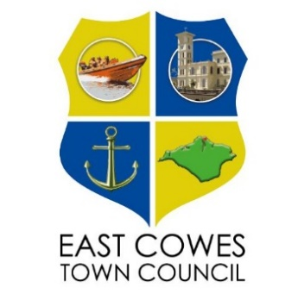

EAST COWES
EQUALITY AND DIVERSITY POLICY
2026

EQUALITY AND DIVERSITY POLICY ¹

STATEMENT OF INTENT - Our Commitment to Equality and Diversity ²

- East Cowes Town Council is committed to providing and promoting equal opportunities, including recruitment; eliminating discrimination and encouraging diversity in the community and will comply with current legislation about diversity and equality and employment law.³ We believe that meeting the needs of our residents and staff can only be achieved through recognising the value of every individual. Our aim is to create an environment that respects the diversity of staff and service users and enables them to achieve their full potential, to contribute fully, and to derive maximum benefits and enjoyment from their involvement with the Town Council.

2 To this end the Town Council acknowledges and strives to embed in all its activities the following basic rights for all:
- To receive a professional and appropriate service
- To be treated with respect and dignity
- To be treated fairly regarding all procedures, assessments and choices
- To receive encouragement to reach their full potential

3 These rights carry with them responsibilities, not just for East Cowes Town Council as a corporate body, but also its staff, volunteers, service users and those who supply services on our behalf. We must all recognise and uphold these rights and act in accordance with them in dealings with others. Councillors and any employees have a personal responsibility for fostering a fully integrated community, at work, by adhering to the principles of equal opportunity⁴ and maintaining racial harmony in the provision of dedicated services to people on equitable terms

4 Statutory duty under the Equality Act 2010⁵
As a public body leading and speaking on behalf of the community the Town Council must play its part in making society fairer by tackling discrimination and providing equality of opportunity for all. The Equality Act 2010 places a new Equality duty on the Town Council to work to:
- Eliminate discrimination, harassment, victimisation and any other conduct prohibited under the Act
- Advance equality of opportunity between persons who share a protected characteristic and persons who don’t share it
- Foster good relations between persons who share a relevant protected characteristic and persons who don’t share it

5 No individual will be unjustifiably discriminated against. This includes, but is not limited to, discrimination because of the following characteristics (known as protected characteristics under the Act)⁶
- Age
- Disability
- Gender/Gender reassignment
- Marital status and civil partnerships
- Pregnancy and maternity
- Race
- Religion and beliefs
- Sexual orientation
- Ethnic origin
- Nationality

6 East Cowes Town Council is aware that the above list is not exhaustive and that there are other forms of discrimination that should not be tolerated
We will engage with people to ensure the service is relevant and meets their needs.
We will empower people to recognise and counter discrimination and be supportive in doing so.
No form of intimidation, bully or harassment will be tolerated.

¹ Equality and Diversity Policy
Councils play a critical role in reducing inequalities and enhancing inclusion and cohesion within their communities. Non-compliance with the Equality Act in decision making by members can lead to a legal challenge and judicial review.
² Statement of Intent – Our Commitment to Equality and Diversity

