East Cowes Town Council
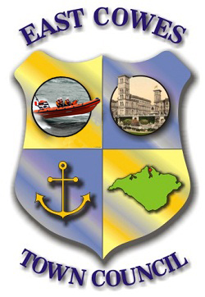
Terms of Reference
Events Committee

1. Roles and Responsibilities
The Committee shall be responsible for:
a) Planning and overseeing an annual events programme.
b) Providing an annual report showing expenditure and income on events (in conjunction with the Town Clerk) to Full Council by November to meet budget projection deadlines.

2. Delegated Powers
The Committee is authorised to make decisions and approve annual expenditure up to a maximum of £5000 without further reference to Full Council, unless either the Committee or Full Council determines that the matter should be referred for Council consideration.

3. Membership
The Committee shall comprise [5] Councillors and up to [3] non-Councillor members. Non-Councillor members may be appointed on a project-by-project basis, subject to approval by the Councillors serving on the Committee.
- Initial appointments will take effect from the establishment of the Events Committee until the next Annual Meeting of the council.
- Thereafter, nominations for membership will be made and confirmed at the Annual Meeting of Full Council for the forthcoming year.
- At its first meeting each year, following the annual meeting of the Council, the Committee shall elect a Chair and Vice-Chair to serve for that year.

4. Quorum
The quorum for any meeting of the Committee shall be a minimum of three Councillors.

5. Voting
Each Councillor shall have one vote, with the Chair holding an additional casting vote in the event of a tie. Non-Councillor members shall not have voting rights. Voting will normally be conducted by a show of hands; however, a recorded (named) vote shall be taken if requested by any Councillor.

6. Committee Servicing
The Committee shall be serviced by the Town Clerk or their deputy.

7. Meetings
Meetings will take place as agreed by the Chair.

8. Confidentiality
All discussions, documents, and information deemed confidential by the Committee must not be disclosed or discussed on public platforms, social media, or with individuals outside the Council unless expressly authorised by Full Council. All members must comply with the Council’s Data Protection Policy and any relevant legislation when handling confidential or personal information.

