East Cowes Town Council

Internal Audit Key Controls Policy
2026
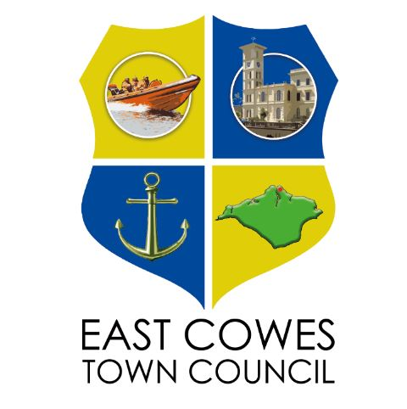

1. Purpose
This policy aligns with the Council's Financial Regulations adopted May 2026 and supports compliance with the Accounts and Audit Regulations 2015 and JPAG guidance.

2. Governance and Responsibilities
Full Council retains responsibility for internal control (as required within Financial Regulations). The Clerk acts as RFO. Oversight is undertaken by Full Council.

3. Banking and Financial Systems
The Council operates banking arrangements in accordance with Financial Regulations, including dual authorisation and member-approved bank mandate. Bank: Unity Trust, East Cowes Town Council.

4. Key Controls
Controls reflect Financial Regulations sections on procurement, payments, payroll, income, assets, insurance and audit requirements and must be always adhered to.

Appendix A: Detailed Internal Audit Checklist
- Cashbook maintained and accurate
- Budget approved and precept properly set
- Procurement follows thresholds in Financial Regulations
- Payments authorised and supported
- Dual authorisation for online banking
- Income recorded and banked
- VAT reclaimed
- Payroll compliant
- Asset register maintained
- Insurance adequate
- Risk assessment reviewed annually
- Internal audit independence confirmed
- AGAR prepared correctly

This policy operates alongside the Council’s Standing Orders. Financial decision-making, procurement, and governance controls must always align with Standing Orders. Any conflict shall default to statutory requirements and Financial Regulations. Regular cross-checks should confirm consistency between procurement rules, committee authority, and decision-making processes.

Approval and Adoption
Adopted by East Cowes Town Council on: _____________
Review Date: ______________
Chair Signature: ______________
The Internal Audit, as outlined above, will need to be carried out twice a year.
This report will form part of the Annual Return, which the Clerk will make on an annual basis, usually during May/June.

