
East Cowes Town Council
Town Hall, York Avenue, East Cowes, Isle of Wight. PO32 6RU
Telephone: (01983) 299082
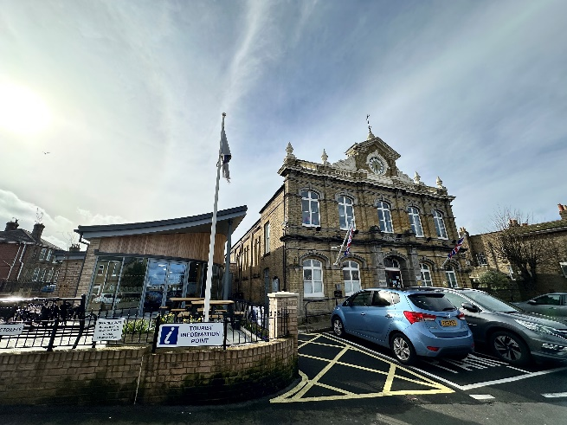
The Town Hall is a beautiful Victorian Building, built in 1897 and is situated in the heart of East Cowes in York Avenue.
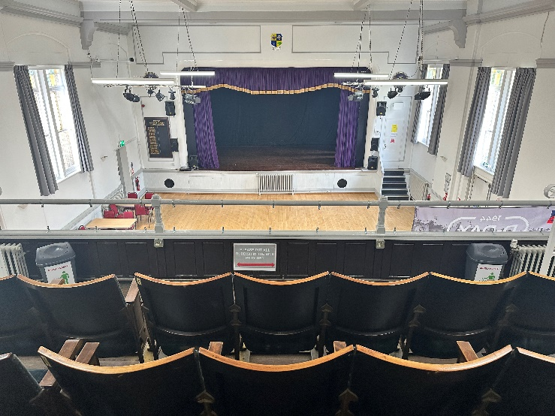
Today the Town Hall is a busy place with the hall in use every day and available to hire from 9am to 11pm. The facilities include a large hall with a stage, a balcony and servery making it a brilliant venue for live music and theatre performances, exercise classes, functions, meetings, fund raising events and local community groups.
The programme of events currently includes Line Dancing, short mat bowls, Paracise, community market, community cinema, regular stage shows and Bingo evenings to name but a few.
East Cowes Town Council is committed to providing and promoting equal opportunities, eliminating discrimination and encouraging diversity in the community and will comply with current legislation about diversity and equality and therefore use by religious or political organisations will only be permitted where all religions or political organisations are included in the event.
Facilities:
The hall size is 15.8 metres x 11.8 metres. The stage is an addition along with the dressing rooms and can accommodate amateur performances.
Seating: The hall can take seating for 160 and 20 standing. There are 57 seats on the balcony; all children using the balcony must be accompanied by a responsible adult at all times. Maximum number is 180 people standing.
We have 34 plastic chairs and 190 banquet seats
Tables: There are 2 large tables (1820 x 700mm), 1 medium table (1500 x 760mm) and 24 small tables (1200 x 700mm).
There are trolleys in place to move the tables and chairs and it is the responsibility of the hirer to put up and take down the tables and chairs unless the hirer has requested and paid for the caretaker to provide this service.
Theatre:
Theatre including use of the stage with basic sound and lights can be hired at an additional cost. Please note that this is only basic sound and lights. For more complex sound and lighting effects we can provide a Sound and Lighting technician at a negotiated additional cost (please see below).

Lighting and Sound Technician: The services of a qualified lighting and sound technician can be hired (depending on availability). There is an extra charge for this service, see Hire Charges below. The technician can provide any/all of the following:
List A
- Lighting Design
- Lighting Engineer
- Sound Technician
- Stage Assistant
- Video recording/live streaming - available later this year
- Audio recording
We may also be able to provide the following items for an additional fee to be agreed and confirmed for each individual booking:
List B
- Additional lighting
- Monitors for audio playback
- Wired Microphones for vocals
- Instrument microphones
- Microphones to cover full drum kit
- DI Boxes
- Smoke Machine
- Wireless Microphones
Servery: The servery area is equipped with a hot drinking water supply, crockery, washing up products and refuse bags but does not include tea towels. The area also includes a Microwave, fridge/freezer and a glass sanitizer unit.
Cleaning: If you have chosen to clean up after your event cleaning equipment is available in the servery and this includes a broom, dustpan and brush and a mop and bucket. Please ensure that you take all your rubbish away with you. (See terms and conditions)
Parking: There is limited parking at the Town Hall. Hirers may use vacant spaces when available, but must not park on, or block, hatched areas at any time as these may be required for emergency access.
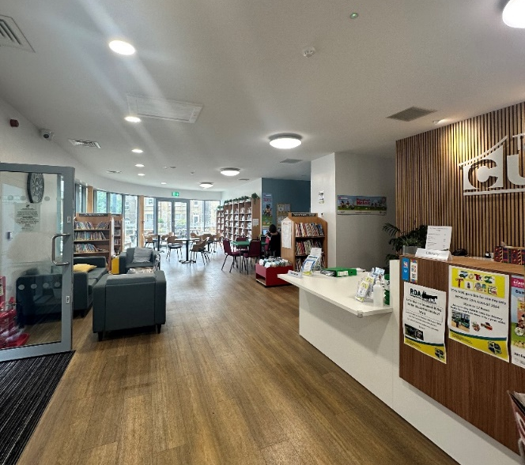
The East Side Curve
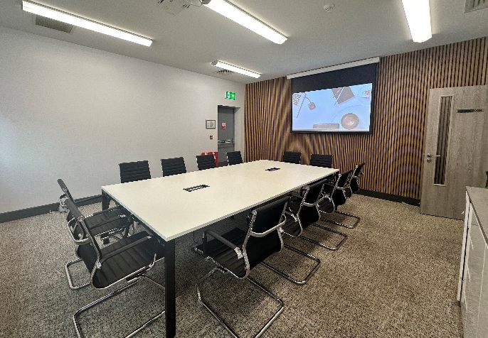
The East Side Curve is our new purpose-built library and community hub. The library offers both adult and children’s books as well as the use of a communal laptop and photo copying facilities. The team are also available to provide any local information, give contact details of local amenities and charities.
Within this space there is also a meeting room available for hire, this can accommodate up to 12 people comfortably and includes a projector and screen.
We have an accessible toilet within the facility and two public toilets off Osborne Road.
We would like to think that the building is a place where people can meet, socialise, maybe play a few games or join the several clubs we will be hosting. We look forward to welcoming you to our new building.


Community Beach Hut, 1 Esplanade
The Beach Hut is a new facility the Council are proud to offer, which is located at 1 Esplanade, looking out over the Solent. The Beach Hut will, primarily, be available for community, charitable, non-commercial and environmental projects. Bookings in these categories will be given priority and there will be no charge for the hire of the hut. Requests for hire by others who do not fall into these categories will be considered by the council and a donation to cover costs will be expected.
In all cases we must have a hire form completed and approved by us at least three weeks in advance of your booking date request.
Keys for the hut are held at the East Side Curve and arrangements will be made for collection/return on receipt of your approved booking. There is no electricity supplied to the hut but there is a camping gas facility which may be used for hot drinks. You will be required to pay for the gas you use.
We have a strictly no- alcohol rule covering the use of the hut, which must be adhered to. Any user contravening this will be banned from future hire.
You will be expected to leave the hut in the same clean and tidy condition that you find it. Any rubbish you have must be taken home, or you will be charged for its removal. The hut will be inspected following your event and any loss or damage to the property will be charged to you (see terms and conditions below). Any photos you are happy to share of your event at the hut would be welcomed by us for our Facebook page.

Hire Costs:
Community cost per hour | Monday to Sunday
Hall and servery | £17.50
Theatre use inc. stage, basic lighting, and basic sound | £12.00
The East Side Curve Meeting Room | £17.50
Commercial cost per hour
Hall and servery | £27.50
Theatre use inc. stage, basic lighting, and basic sound | £12.00
The East Side Curve Meeting Room | £17.50
Additional costs
Caretaker – additional cost for set up and take down including cleaning | £15.00 per hour
Lighting & Sound Technician | £20.00 per hour
Rubbish removal (if left in the hall or outside) | £8.00 per bag
Security – the cost of unlocking & locking services for all out of hours bookings (Office hours Monday to Friday 9am to 5pm) | £15.00 per booking

East Cowes Town Council reserves the right to alter the scale of charges at any time without prior notice, provided that the amended scale of charge does not apply to any contracts for hire already in place.

East Cowes Town Council
Assistant Facilities Officer: Denise Adams
Town Hall, York Avenue, East Cowes, Isle of Wight. PO32 6RU
Telephone: (01983) 299082 Email: assistantfacilities@eastcowestowncouncil.gov.uk

Thank you for your booking enquiry. Please complete both sides of this form. This booking will only be confirmed when a completed, signed form is returned to the above address with payment.
Hire Form
Name of Hirer | Organisation (if applicable)
Contact Number | Email Address
Address

Postcode
Purpose of use

Date required | Time from | Time until
 | Including time for setting up and tidying away afterwards (if not using Caretaker service)
Facilities required:
Community Hub – meeting room/library space

Hall and servery only

Hall, servery, theatre (includes balcony, stage and dressing rooms)

Sound & Lighting Technician (List A)
Sound and Lighting – Additional items – charge to be agreed (List B)
Caretaker – To set up and take down and clean
Rubbish removal

Security – To unlock and lock up before and after the hire

Will alcohol be sold at this event? | Yes |  | No
Beach Hut – Hire approved and arrangements for key collection/return | Yes |  | No
If you have ticked yes to this question, please provide us with the Licence’s name and provide a copy of the license.
Please provide a copy of your Public Liability (if relevant to your booking. Please refer T’s & C’s).
Please provide a copy of your PRS license (if relevant, for example exercise classes with music).
If you are bringing in electrical equipment, please provide copy of an annual electrical certificate (PAT testing).
If you have staff/coaches delivering your sessions for children or adults at risk by signing this hire form you are stating that they have been DBS checked.

Community use including children’s birthday parties
Hall hire Monday – Sunday £17.50 per hour | Theatre use inc. stage, lighting and sound  £12 per hour | Community Hub – Meeting Room  £17.50 | Beach Hut  Zero charge | Time from | Time until | No of hours | Cost | Any additional costs – cleaning or unlocking and locking | Total cost

Commercial use
Hall hire Monday – Sunday £27.50 per hour | Theatre use inc. stage, lighting and sound  £12 per hour | Community Hub – Meeting Room  £17.50 | Time from | Time until | No of hours | Cost | Any additional costs – cleaning or unlocking and locking | Total cost

PAYMENT:
CHEQUES: made to East Cowes Town Council and returned with this completed form.
BACS: East Cowes Town Council Reference: Hall Hire
Sort Code: 60 – 83- 01 Account No: 20340944
I understand and agree to the Terms and Conditions as stated in the Hire Form and will at all times observe all health and safety and fire procedures.
Signed: ____________________ (The Hirer) Print name: ____________________ Date: ___________
PLEASE SIGN AND RETURN THIS FORM TO EAST COWES TOWN COUNCIL
If you have any enquiries about your booking, please contact us on (01983) 299082.
To be completed by East Cowes Town Council only
Total amount paid: £ _____________________ Booking confirmed for date: ______________________
Signed: _____________________ Town Council representative Dated: _______________________
Public Liability Expiry date: _______________________ Bar Licence certificate No: __________________
PRS License ________________________________ DBS checks in place ________________________
Status: Occasional booking/Regular booking

PLEASE KEEP THIS COPY FOR YOUR RECORDS
TERMS AND CONDITIONS OF HIRE

THE HIRER

- The Hirer shall, during the period of hire be responsible for the behaviour and supervision of all people in the hall including when entering and leaving the venue so as not to cause a disturbance to our neighbours.

- The Hirer must ensure the interior and exterior of the building are kept free of damage at all times throughout the hire.

- The Hirer will pay the Town Council for the cost of repair of any damage caused to any part of the property, or to its contents which may occur during the period of hire, or as a result of the hire.

- If hiring for parties/events and children’s’ parties, the Hirer shall ensure that there is a minimum of two adults (18+) in attendance at all times throughout the period of the hire.

- The Hirer and any other designated responsible adult must be aware of the position of the
Fire exits and Fire extinguishers ensuring they are fully accessible at all times and make themselves aware of the evacuation procedure and the location of the first aid kits. (Copy attached). The hirer will record the number of people attending the event for fire evacuation purposes.

- The Hirer shall not sub-hire the premises or use the premises for any other purpose than that described in the hire agreement.

- The Hirer shall not permit the premises to be used for any unlawful purpose or used in any unlawful way.

- For hirers who are running commercial/entertainment events/sessions a copy of their Public Liability Insurance should be provided and/or a copy of their PPL/PRS licence.

- If the event/hire is a commercial venture and involves the attendance of anyone under the age of 18 without their parents or are classed as ‘adults at risk’, you must confirm that there will be an appropriate Child Protection and Adults at Risk policy/procedure in place. You agree to ensure that all adults involved in the running of the session are aware of this/these documents, abide by it and where necessary appropriate DBS checks have been carried out.

- The Town Council reserve the right to cancel regular bookings if required to accommodate a town/community/charity event and for maintenance issues.

BOUNCY CASTLES/CHILDREN’S RIDE ON TOYS

- Please let us know if you are using a bouncy castle during your hire. Please be aware that we do not allow any wheeled toys including bikes, scooters, skates etc. to be used in the hall.

BALCONY USE

- The use of the balcony is by written permission only and is subject to the following conditions: that the hirer ensures a competent adult stays on the balcony at all times throughout the hire period, to ensure safety of all children/adults and to control evacuation of the building in the case of fire or emergency; and that no child under the age of 11 years is allowed on the balcony unsupervised; all children (11+) must be accompanied by a responsible adult.

LICENCES

- The Hirer shall obtain written consent from the Town Council before alcoholic liquor is bought or sold on any part of the premises.

- A temporary licence permitting the sale of alcohol must be obtained from the Isle of Wight Council 21 days in advance of the event and a copy presented to the Town Council prior to the booking.

- The premises shall only be used for public entertainment between the hours of 9.00am and 11.00pm.

- The Hirer shall comply with all conditions and regulations made in respect of the premises by the Isle of Wight Council, Licensing Authority or any other Statutory or Regulatory Body, particularly in connection with any event which includes public dancing, music, stage shows or other similar public entertainment.

STORAGE OF GOODS OR BELONGINGS
- Permission must be obtained from the Town Council before goods or equipment are left stored on the premises, and the Hirer shall undertake to ensure that all goods or effects so stored shall be kept in an orderly manner in the area designated for the purpose by the Town Clerk and are properly secured and insured. The Town Council shall be provided with keys to any locks or padlocks used to secure storage of any equipment and with a full inventory of all items stored.

- The Town Council shall not be responsible for loss, theft or damage to the Hirer’s property and/or effects brought on to the premises, whether permanently or temporarily stored.

ELECTRICAL APPLIANCES BROUGHT INTO THE PREMISES
- The Hirer shall provide the Town Council with an annual certificate of testing in respect of all their electrical equipment stored or used on the premises during the hire.

NO SMOKING
- The Town Hall, East Side Curve and Beach Hut are strictly NO SMOKING areas at all times; this includes e-cigarettes and vapes. This also includes lighted candles or naked flames.

END OF HIRE FOR HIRERS NOT PAYING FOR CARETAKERS SERVICES
- The Hirer shall at the end of the hire, be responsible for leaving the premises and outside surrounding areas in a clean and tidy condition, including the removal and disposal of all empty bottles, unused foodstuffs and other rubbish caused during the period of hire and shall ensure that all electrical appliances are turned off, unless otherwise directed. Black sacks are provided in the drawer by the sink. All rubbish should be bagged, tied and taken away and not left in or outside the hall. An additional charge will be incurred if this is not done.

- The Hirer is responsible for leaving the hall clear of tables or chairs and ensure all tables and chairs are stacked safely as found. This is at the hirers own risk. Trolleys to move the tables and chairs are provided. An additional charge will be incurred if this is not done.

- Any damage which occurred during the hire must to be notified to the Caretaker or the Town Clerk as soon as practicable.

KEYHOLDER SERVICES
24. If you are using the keyholder services please contact the person on duty if you are leaving early, to ensure that the building is locked up and secure as soon as you leave.
CANCELLATION BY HIRER

- Should the Hirer wish to cancel the booking before the date of the event and the Town Council is unable to confirm a replacement booking, the repayment of any fee shall be entirely at the discretion of the Town Council.

- All regular block bookings must give 1 weeks’ notice of cancellation of any dates or may be charged at the discretion of the Town Clerk.

CANCELLATION BY TOWN COUNCIL

- The Town Council reserve the right to cancel any booking in the event of the Town Hall being required for use as a Polling Station or a Parliamentary or Local Government Election or By Election or any Town Council meeting or any other emergency purpose in which case the Hirer shall be entitled to a full refund of any fee already paid.

- In the event of the Town Hall being rendered unfit for the use for which it had been already hired by whatever circumstances, the Town Council shall not be liable to the hirer for any losses incurred.

SPECIAL CONDITIONS OF HIRE

- From time to time, it may be necessary to issue special conditions of hire which hirers will be asked to sign.

