East Cowes Town Council

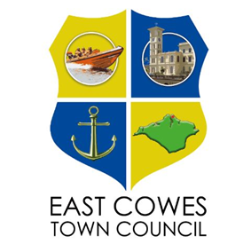

Commemoration Policy

1. Purpose
This policy outlines the criteria and process for commemorating individuals, particularly former parish councillors, through naming or other forms of recognition within the town of East Cowes. It ensures that such honours are granted fairly, transparently, and in alignment with the values and history of the community.

2. Objectives
- To honour the legacy and service of individuals who have positively impacted East Cowes.
- To ensure commemorative actions are appropriate, inclusive, and aligned with Council values and policies.
- To guide decision-making through clear criteria and procedures.
3. Scope
This policy applies to all proposals for commemorative naming or installations within East Cowes, including but not limited to:
- Buildings
- Rooms
- Parks
- Benches
- Plaques
- Other public assets or spaces under the jurisdiction of East Cowes Town Council

4. Principles
Commemoration should reflect the values, heritage, and identity of East Cowes.
Recognition shall be based on:
- Merit
- Contribution to the community, and
- Community impact
Decisions will be made with sensitivity, inclusivity, and respect for all parties involved.

5. Eligibility Criteria
Naming or commemoration will typically be considered only after an individual’s passing. In exceptional circumstances, living individuals may be recognised if their formal or voluntary association with the Council has concluded. Serving council staff, councillors, and individuals who maintain an active formal relationship with the Council are not eligible for naming or commemoration.
Commemoration or naming may be considered for individuals who meet one or more of the following criteria:
- Have served as an East Cowes Town Councillor for a minimum of one full term, or as Mayor of East Cowes for at least two terms, default would be one minute’s silence.
- Have made a significant and lasting contribution to the town of East Cowes.
- Have played a key role in Town Council initiatives or in the development of the East Cowes community.
- Are widely recognised and respected within the community for their positive contributions to East Cowes.
- Have demonstrated exceptional service, achievement, or a notable association with the town.

6. Submission of Proposals
Proposals for commemoration or naming must be submitted using the official application form and may be made by:
Town Councillors
Individual residents
Charitable organisations
Community groups, clubs, or other local organisations
All proposals must be provided in writing and include sufficient information to support the nomination.

7. Process
The Town Council will evaluate all proposals against the established eligibility criteria.
Where applicable, consultation will be undertaken with the next of kin of the individual being proposed.
Final recommendations will be made by resolution of the Town Council and are subject to final approval by the Isle of Wight Council.
The coordination of signage and commemorative installations will be managed by the Town Council. Associated costs will be met either by the Council or the proposing party, subject to mutual agreement.

8. Review and Amendments
This policy shall be reviewed biannually to ensure it remains relevant, respectful, and aligned with community expectations and Council priorities. Amendments must be approved by resolution of the Town Council.

