East Cowes Town Council

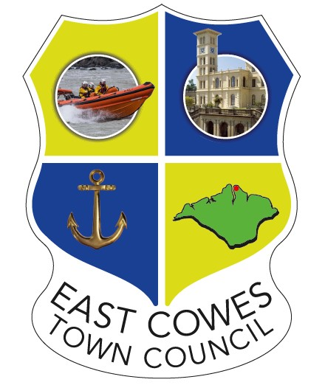

Alcohol on Council Premises Policy
2026

1. Purpose
This policy sets out the rules governing the consumption, sale, and supply of alcohol on all council-owned or council-managed premises. It applies to council staff, elected members, hirers, contractors, and members of the public.

2. Objectives
To ensure that all activities involving alcohol are conducted safely, lawfully, and in a manner that does not cause nuisance or disturbance to the local community.

3. Scope
This policy applies to all council-owned or council-managed premises, including (but not limited to) East Cowes Town Hall and the East Side Curve.

4. Permitted Alcohol Use
1 BYOB – Bring Your Own Bottle - Community, Private Hire and Charity Events
BYOB may be permitted only at the discretion of the Town Council and with its prior consent. This applies solely to approved private, charity, or community events. Alcohol brought by attendees may be consumed free of charge only during events where all hall hire conditions have been strictly complied with and formally agreed in advance.

- Sale of Alcohol - Commercial Events
- Licensing and Public Liability Insurance

Where alcohol is sold (including where it is included in the ticket price or provided via a cash bar), a valid Premises Licence must be in place, or a Temporary Event Notice (TEN) must be issued by the relevant licensing authority. Valid Public Liability Insurance is also required. Evidence of all such documentation must be provided to the Town Council prior to the event taking place.
- Advertising
All event advertising must be submitted to the Town Council for approval prior to publication and must clearly state where BYOB is not permitted.
- Capacity
The maximum capacity of the venue, as stated in the relevant premises licence, must not be exceeded at any time.
- Supervision
A designated responsible person must be appointed to oversee safety and compliance throughout the duration of the event.

5. Safety and Prevention of Nuisance
- Waste Management:
Hirers must ensure that all bottles and alcohol-related waste are disposed of appropriately and are not left in public or external areas.
- Security:
For larger events, the Town Council may require the provision of adequate, registered security personnel.
- Noise Control:
Music and the supply or consumption of alcohol must cease at the times specified on the relevant licence and/or hire agreement in order to prevent public nuisance.
- Prohibited Areas: The consumption of alcohol is strictly prohibited in public areas adjacent to East Cowes Town Hall and the East Side Curve unless specifically authorised under an appropriate licence.

6. Breach of Policy
Any breach of this policy may result in the immediate termination of the event and the forfeiture of any hire charges paid.

