East Cowes Town Council

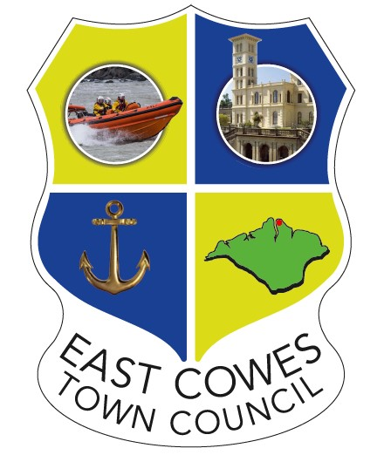

Advertising Policy
2026

1. Purpose
This policy sets out the principles and conditions under which advertising may be displayed within buildings owned or managed by East Cowes Town Council. Its purpose is to ensure that any advertising permitted supports the local community, maintains the Council’s neutrality, and preserves the professional appearance and integrity of Council premises.

2. Policy Statement
East Cowes Town Council recognises that permitting advertising within public buildings is a matter of local discretion. While there is no legal prohibition on allowing advertising, the Council must balance potential community benefit against the risks of perceived commercial favouritism, visual clutter, and reputational damage. Any advertising permitted must be managed transparently, fairly, and consistently in accordance with this policy.

3. Scope
This policy applies to all advertising displayed within Council-owned or Council-managed buildings, including but not limited to:
- East Cowes Town Hall
- The East Side Curve
The policy applies to noticeboards, display stands, and any other internal public display areas.

4. Key Principles
When considering advertising requests, East Cowes Town Council will be guided by the following principles:
- Community Benefit
Priority will be given to advertising that supports the residents of East Cowes, including, community groups, charities, voluntary organisations, and local events and commercial hirers of the Town Hall or Curve.
- Appearance and Maintenance
Advertising must not detract from the appearance, cleanliness, or dignity of Council buildings. Excessive, outdated, or poorly presented material will not be permitted.
- Content Standards
Advertising must not promote illegal activity or socially contentious or harmful products or services, including but not limited to gambling, alcohol, or unhealthy food and drink.
- Legal Compliance
All advertising must comply with relevant legislation and Advertising Standards Authority (ASA) codes and must be legal, decent, honest, and truthful.
- No Endorsement
The display of any advertisement does not constitute endorsement by East Cowes Town Council of the organisation, product, or service advertised.

5. Permitted Advertising

- Non-Commercial Advertising:
Advertising will be permitted for community groups, charities, voluntary organisations, and local events that support the residents of East Cowes

- Commercial Advertising:
Subject to prior approval, advertising may be permitted only in connection with commercial hirers of East Cowes Town Council buildings. Any such advertising must relate directly to an event, activity, or service being delivered by the hirer within the relevant Council premises. Advertising may be displayed only for the duration of the approved hire period, including reasonable set-up and take-down times as agreed in advance. All advertising materials must be removed immediately at the end of the hire period unless otherwise authorised in writing by the Council. No other commercial advertising will be permitted unless expressly approved by East Cowes Town Council.

6. Restrictions
- Size and Format
Advertising materials will normally be limited to A4 size (or smaller) unless otherwise agreed in writing. All materials must be suitable for display on designated noticeboards or approved display areas only.
- Feather Flags and Pop-up Banners will only be permitted with the prior approval of the Council
- Location
Advertising may only be displayed in locations approved by the Council or its officers.
- Duration
Advertising may be displayed only for the duration of the approved hire period. The Council reserves the right to remove expired, damaged, or unauthorised material without notice.

7. Approval and Review Process
- All advertising requests must be submitted to the Town Clerk or a designated officer for approval prior to display.
- The decision of East Cowes Town Council, or its delegated officer, regarding the acceptance or refusal of advertising is final.

8. Removal of Advertising
East Cowes Town Council reserves the right to remove any advertising at any time if it:
- breaches this policy.
- becomes inappropriate or outdated; or
- adversely affects the appearance or reputation of the Council or its buildings.

9. Review of Policy
This policy will be reviewed periodically by East Cowes Town Council to ensure it remains appropriate, effective, and aligned with the Council’s legal responsibilities and community objectives.

